Prayers to finish…
May God’s grace be upon this shawl,
warming, comforting, enfolding and embracing.
May this shawl be a safe haven,
a sacred place of security and well-being,
sustaining & embracing in good times as well as difficult.
May the one who receives this shawl be cradled in hope,
kept in joy, graced with peace, and wrapped in love.

Prayers to gift…
May this prayer shawl enfold you in warmth, comfort,
healing and peace.
Knitted by hand and threaded with prayers
of love and hope,
This shawl is a gift for you.
May it bring blessings of comfort, gifts of warmth
And the knowledge that you are loved.
Just a simple prayer shawl, Made with prayers for you
To cover you with blessings.
For times you're going through.
I pray that wrapped around you,
You’ll feel your Saviours arms, Holding you and loving
you And keeping you from harm.
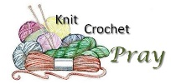
For more information and enthusiasm please speak with
Beth Theis
705-627-2606
Beth.theis@alumni.utoronto.ca
Mary Elizabeth Piercy
705-445-4740
maryelizabethpiercy@gmail.com

Trinity Shawl Ministry
Sharing God’s love, One Shawl at a Time

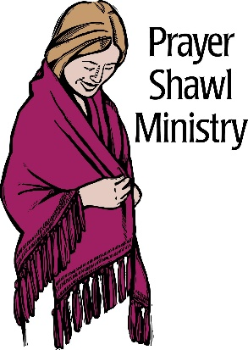
“Shawls...
made for centuries
universal and embracing.

Symbolic of an inclusive
unconditionally loving, God.

They wrap, enfold, comfort, cover, give solace, mother, hug, shelter
and beautify.

Those who have received these shawls have been
uplifted and affirmed, as if given wings to fly
above their troubles…”
Written in 1998 by: Janet Severi Bristow Copyright ©2019

About The Shawls
In 1998, Janet Bristow and Victoria Galo, two graduates of the 1997 Women's Leadership Institute at The Hartford Seminary in Hartford, Connecticut started this ministry as a result of their experience in this program of applied Feminist Spirituality under the direction of Professor Miriam Therese Winter, MMS.
Care and the love of knitting (and crochet) have been combined into a prayerful ministry that reaches out to those in need of comfort and solace. Many blessings are knitted into every shawl. The knitter begins each shawl with prayers for the recipient. Intentions are continued throughout the creation of the shawl. When the shawl is completed it is offered a final
ritual before being sent along its way.
Besides knit & crochet; shawls can be woven, sewn, quilted,
machine knitted, etc.
Some uses for the shawl
Undergoing medical procedures; as a comfort after a loss, during bereavement, prayer or meditation, commitment or marriage ceremonies, birth of a baby…ministering to others or just socializing…there are endless possibilities.

Basic Knit Pattern for Classic Prayer Shawl
Size: One Size
Approximately 24 inches x 60 inches; exact size is not important.
The weight of the yarn and the size of needles will determine the number of stitches you need to cast on.
Shawl
Cast on 63 stitches or any multiple of three, such as 54, 57, or 60.
First row Knit 3, purl 3 to the end of the row.
Repeated row Turn and knit the purl stitches and purl the knit stitches.
Work about 2½ skeins in this pattern. Use the rest of the yarn for fringe, which can be from 3 inches to 9 inches long. Knot the ends of the fringes to keep the yarn from frizzing.

Symbolism in the Pattern of Three
The repeating pattern of three in the prayer shawl patterns is representative of the Christian Trinity (Creator – Christ - Spirit) and is also an important number in many other faiths, including Buddhism, Taoism, and Hinduism; and in many cultures, including Chinese and Egyptian.
Further information www.shawlministry.com
Basic Crochet Pattern for Classic Prayer Shawl
Size: One Size
Approximately 24 inches x 60 inches; exact size is not important.
The weight of the yarn and the size of the crochet hook will determine the number of stitches you need to chain.
Shawl
Loosely chain 54 stitches or the number needed for the desired width of the shawl.
Row 1: Chain 1, turn, single crochet in each ch across
Row 2: Chain 2, turn, half double crochet in the top of each single crochet across..
Row 3 & 4: Repeat row 2.
Row 5: Chain 1, turn, single crochet in each ch across
Repeat the pattern of Row 1 to 4 until desired length has been reached.
End with 1 row of single crochet.
Weave in ends.
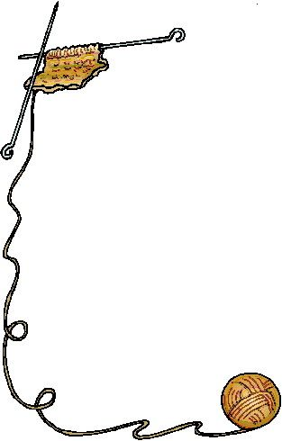
Finish with a fringe

Prayers to Start…
Dear Lord, please bless these needles of mine, that I may make a shawl of strength, faith, hope and love.
May the recipient know that they are cared for and loved and prayed for.
In the soft folds of this cloth, may they know the close presence
of your loving care that brings strength and hope no matter what challenges lie ahead..

