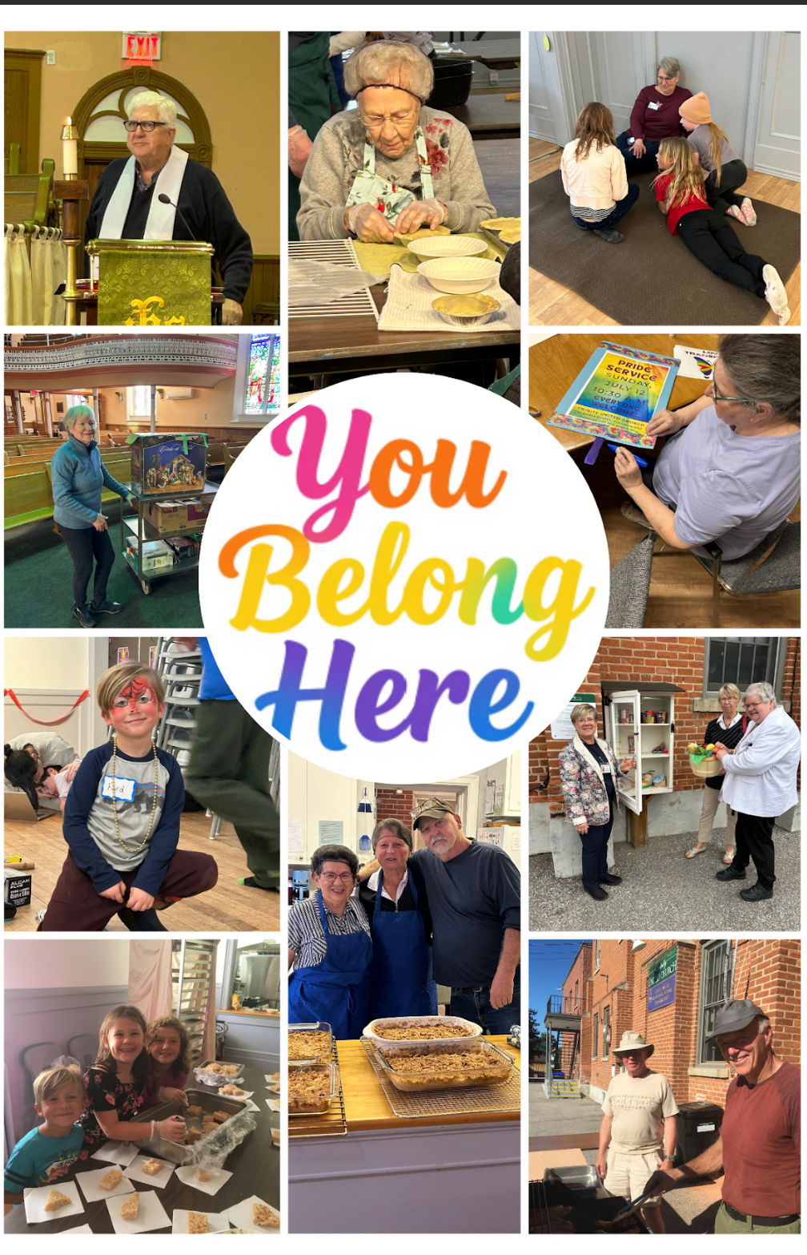


Trinity United Church
September 20, 2026
Ordinary Time
Seventeenth After Pentecost
“You Belong Here”

Land Acknowledgement Explanations (please be seated)

God Welcomes Each One of Us with Loving Grace

Lighting the Christ Candle
We light this candle as a reminder of our commitment to follow in the way of Jesus.

Introit: TLUS 150 “Here in this Place” Words and Music: Maria Case (see insert)

Announcements and Opportunities @Trinity

Gathering Words
One: As an Affirming congregation of The United Church of Canada, we seek to be an inclusive and safe community, nurturing spiritual growth, responding to community and world needs, where everyone feels at home and no one feels alone.
All: We are all invited guests of God.

Opening Hymn: MV 79 “Spirit, Open My Heart”

Opening Prayer
Loving God, as we gather for worship, we hope that you will help us to live out our core value of belonging. Help us to be a safe, caring and nurturing community of faith where everyone can feel they belong. Show us how to celebrate diversity and equality of people of every race, age, ethnic and cultural origin, religious affiliation, social and economic circumstances, physical and mental abilities, sexual orientation, gender identity, or family configuration. Give us the wisdom to respect our differences and to be open to new ideas rather than fearing them. May we be a church family that loves, serves and encourages one another every day. In Jesus’ name we pray. Amen.

Prayer of Confession
Inviting God, “everyone welcome” is so easy to say and so hard to live out. Forgive us when we let our assumptions and prejudices get in the way of truly meeting people where they are at. Free us from every pattern of thought, word and deed that gets in the way of cherishing each person as beloved child of God.

Pause for silent reflection

Assurance of Pardon
In God’s love, we are made new each day. Let us open our hearts to the grace which is the ground of our being. We are a forgiven people. Thanks be to God.

Theme Conversation (Children’s Time) – “Belonging”

Hymn -TLUS 30 “We’re the Light of all the World” (see insert)

God Speaks to Us with Peace and Assurance

Prayer for Illumination (modified from a prayer by Worship@North)
O Wisdom Divine, just as you inspired the ancestors of our faith, grant us your knowledge and discernment so that we can learn how to be clever in our compassion and courageous in our faith, through Christ and in the Spirit. Amen.

Epistle: Ephesians 2: 19-22 (The Message Paraphrase)

Psalm 149 (VU 873, refrain 1)

Gospel: Matthew 15:21-28

Anthem: TLUS148 “We Have Been Called”

Message: “You Belong Here”

Hymn - MV 154 “Deep in our Hearts”

God Supports and Lifts Us

Pastoral Prayer and Prayer of Jesus (sung TLUS 70, see insert)

Acknowledging our Offerings in Support of Trinity United’s ministries
The ministry of the church is sustained by the gifts of the people of God — gifts of time, gifts of ability, gifts of energy, gifts of wisdom and gifts of money. We need everyone’s gifts to be the church in this time and place. If you are able to support us financially, cash or cheques can be left in the offering plate at either entrance or mailed or dropped off at the church office. You can also give by e-transfer to office@collingwoodunitedchurch.ca or by signing up to donate monthly through PAR. If this is your first donation, please make sure we have your name and address and email address (if available) for tax receipt purposes. Thank you for all the ways you support us with your time, your talents and your financial resources. With grateful hearts we pray:

Loving God, bless these gifts, and bless the givers and the recipients so that we may all know your love and grace. Amen.

Closing Hymn - VU 232 “Joyful, Joyful"

Commissioning (from re:worship)
As you go from here, remember to love. For love is what God asks of us; it is the very heart and soul of what it means to follow Jesus Christ. So go from here to love and serve God by loving and serving those you meet.

Benediction (from re:worship)
And may God— who loved us first, and who showed us what real love looks like— be with you and among you wherever you find yourself in the coming week. Go in peace! Amen.

Choral Blessing - VU 962 “May the Blessing of God”

Music to Inspire Our Serving

******************************************************************************

