Announcements

Monday, September 21
UCW Executive meeting Board room 1:00p.m.
UCW unit meeting Banquet hall 2:00p.m.
Prayer shawl group Board room 1:30p.m.
Beaver Valley band Banquet hall 5:30p.m.
Choral works Sanctury 7:00p.m.

Tuesday, September 22
Bay Haven Service Bay Haven 10:00a.m.
Bell practice Banquet hall 7:00p.m.

Thursday, September 24
Thursday night group Banquet hall 7:00p.m.

Choir start up dates
Beaver Valley Concert Band:
Every Monday 5:30 - 8:00 (Start up Sept. 14)

Bay Wind Flutes Ensemble: Alternate Wednesdays:
5:00 - 6:30. (Start up date to be announced)

Adult Choir: Every Wednesday 7:00- 8:40
Start up Date Wed. Sept. 9

Orange Shirt Sunday – Wear your Orange Shirt on Sunday September 27 as we observe Orange Shirt Day (September 30) UCRD has Orange Shirts for sale but you can wear anything orange that you have. Find out more at:
https://ucrdstore.ca/collections/every-child-matters-orange-shirt?srsltid=AfmBOorHh00jVpJjCjYefAz2KwTYcT_KuDDQ63MivfI3xemRmnw655Ay

Wanted for Kid’s Party Empty clean glass jars without labels but with their lids from things like pickles. They don’t all have to be the same size or shape. Please bring clean jars to the office by September 27
Adult Book Study
Valley of the Birdtail an Indian reserve, a white town and the road to reconciliation.
Mondays from 10:00 – 11:30 September 14, 21, 28 and October 5
Through the tale of two towns (Rossburn and Waywayseecapo) learn more about racism, the Indian Act, Residential Schools, and the way forward.
Contact Beth about getting a copy from the library book club kit and which chapters we are discussing each week.

Prayer Shawl Meeting
Prayer shawl meeting will be meet on the following dates.
Please take not there will only be one date in October due to the Thanksgiving holiday.
September 28, October 26, November 9, 23 beginning at 1:00pm.

UCW Meat pies
The UCW will be making meat pies on October 1
Meat pies will be ready for pick up at1:00p.m.
Price $7 per pie
Sign up sheet on the fridge in the kitchen for pie orders.
Any help with making the pies and putting on lids is much appreciated. For additional details please see Joy Barr

Men’s Social
Come join the men’s social hour for conversation, coffee and pastries.
October 5 @10:00am in the Banquet hall

Member of Affirming Ministry Committee, Trinity
United Church Collingwood
Are you interested in the opportunity to:
· support our congregation in faithfully living out its Affirming Ministry commitment
· ensure that everyone can feel they belong and where all people are valued?
We are now looking for committee members to join our new Affirming Ministry Committee here at Trinity United Church.
For the full job description and with any questions please contact :
· Beth Theis:
705-627 2606 or beth.theis2@alumni.utoronto.ca,
· Bev Mayberry:
705-606-0565 or mayberrybev@gmail.com or
· Trinity Church office: 705-445-3901
Looking forward to hearing from you!

Rev. Beth Kerr (she/her)
Diaconal Minister
Trinity United Church
140 Maple Street,
Collingwood, ON L9Y 2P8
www.collingwoodunitedchurch.ca
705-445-3901 (church)
204-872-2370 (cell)
Please note: Friday and Saturday are my sabbath days. I will reply to emails received on those days on the following Monday. For emergencies, please contact my cell phone.

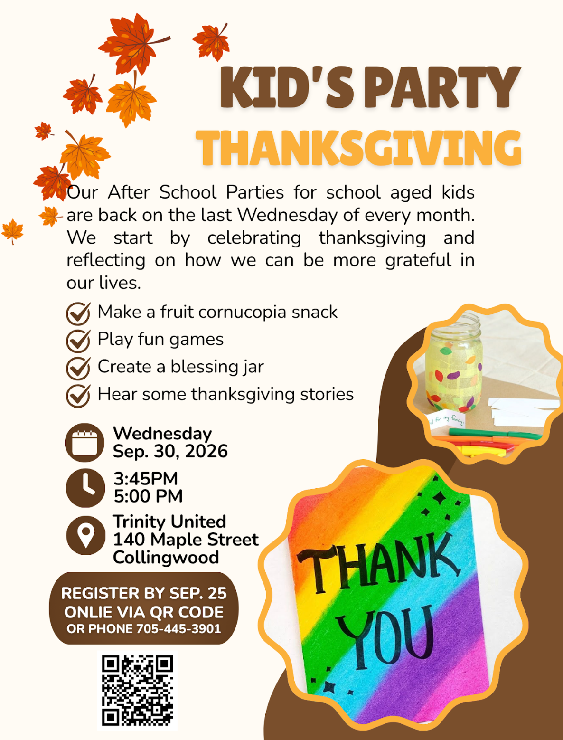

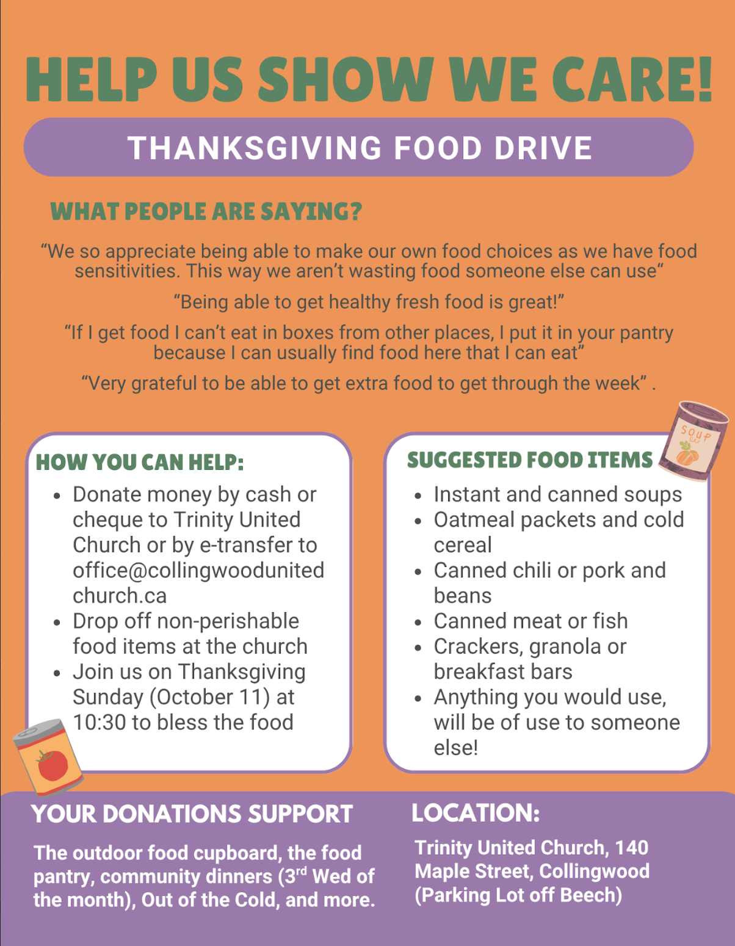
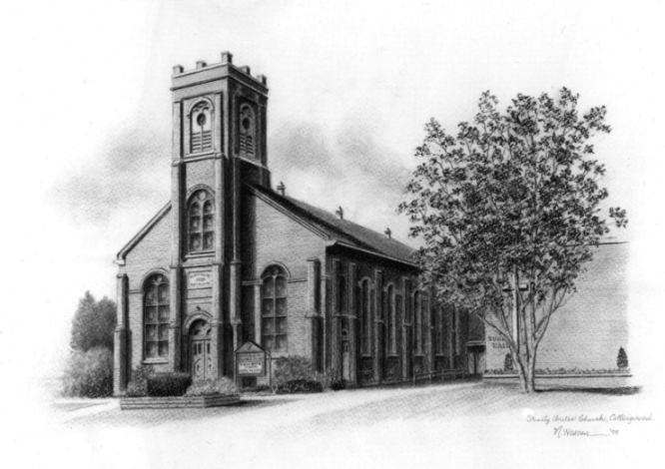

Trinity United .Church: Collingwood
Minister: Rev. Beth Kerr, 204.872.2370 (cell)
Minister’s Email minister@collingwoodunitedchurch.ca
Ministry of Music: Paul Sloan, 705.730.3121 (cell)
Choir Director: Lesley Joosten, 705.984.3243
Handbell Director: Maryellen Burgess, 705.443.1422 (cell)
UCW President: Joy Barr 705.445.0726
Office Assistant: Lori Forsythe
Church Office: office@collingwoodunitedchurch.ca
Office Hours: Tuesday to Friday, 8:30 am-12:00 pm
140 Maple Street, Collingwood, ON L9Y 2P8
Telephone: 705.445.3901
Website: www.collingwoodunitedchurch.ca

