Announcements

Monday, October 5
Men’s Social group Library 10:00a.m.
Crock pot program Banquet hall 10:00a.m.
Study group Board room 10:00a.m.
Beaver Valley band Banquet hall 5:30p.m.
Choral works Sanctury 7:00p.m.

Tuesday, October 6
Affirming group Board room 4:00p.m.
Bell practice Banquet hall 7:00p.m.

Wednesday, October 7
Horticulture group
Pumpkin center pieces

Thursday, October 8
Building and grounds Board room 7:00p.m.
Thursday night group Banquet hall 7:00p.m.

Adult Book Study
Valley of the Birdtail an Indian reserve, a white town and the road to reconciliation.
Mondays from 10:00 – 11:30 September 14, 21, 28 and October 5
Through the tale of two towns (Rossburn and Waywayseecapo) learn more about racism, the Indian Act, Residential Schools, and the way forward.
Contact Beth about getting a copy from the library book club kit and which chapters we are discussing each week.

Men’s Social
Come join the men’s social hour for conversation, coffee and pastries.
October 5 @10:00am in the Banquet hall

Affirming group
Affirming Group will meet Tuesday, October 6, 4:00 pm, Hybrid Boardroom + Zoom.

Member of Affirming Ministry Committee, Trinity
United Church Collingwood
Are you interested in the opportunity to:
· support our congregation in faithfully living out its Affirming Ministry commitment
· ensure that everyone can feel they belong and where all people are valued?
We are now looking for committee members to join our new Affirming Ministry Committee here at Trinity United Church.
For the full job description and with any questions please contact :
· Beth Theis:
705-627 2606 or beth.theis2@alumni.utoronto.ca,
· Bev Mayberry:
705-606-0565 or mayberrybev@gmail.com or
· Trinity Church office: 705-445-3901
Looking forward to hearing from you!
Rev. Beth Kerr (she/her)
Diaconal Minister
Trinity United Church
140 Maple Street,
Collingwood, ON L9Y 2P8
www.collingwoodunitedchurch.ca
705-445-3901 (church)
204-872-2370 (cell)
Please note: Friday and Saturday are my sabbath days. I will reply to emails received on those days on the following Monday. For emergencies, please contact my cell phone.



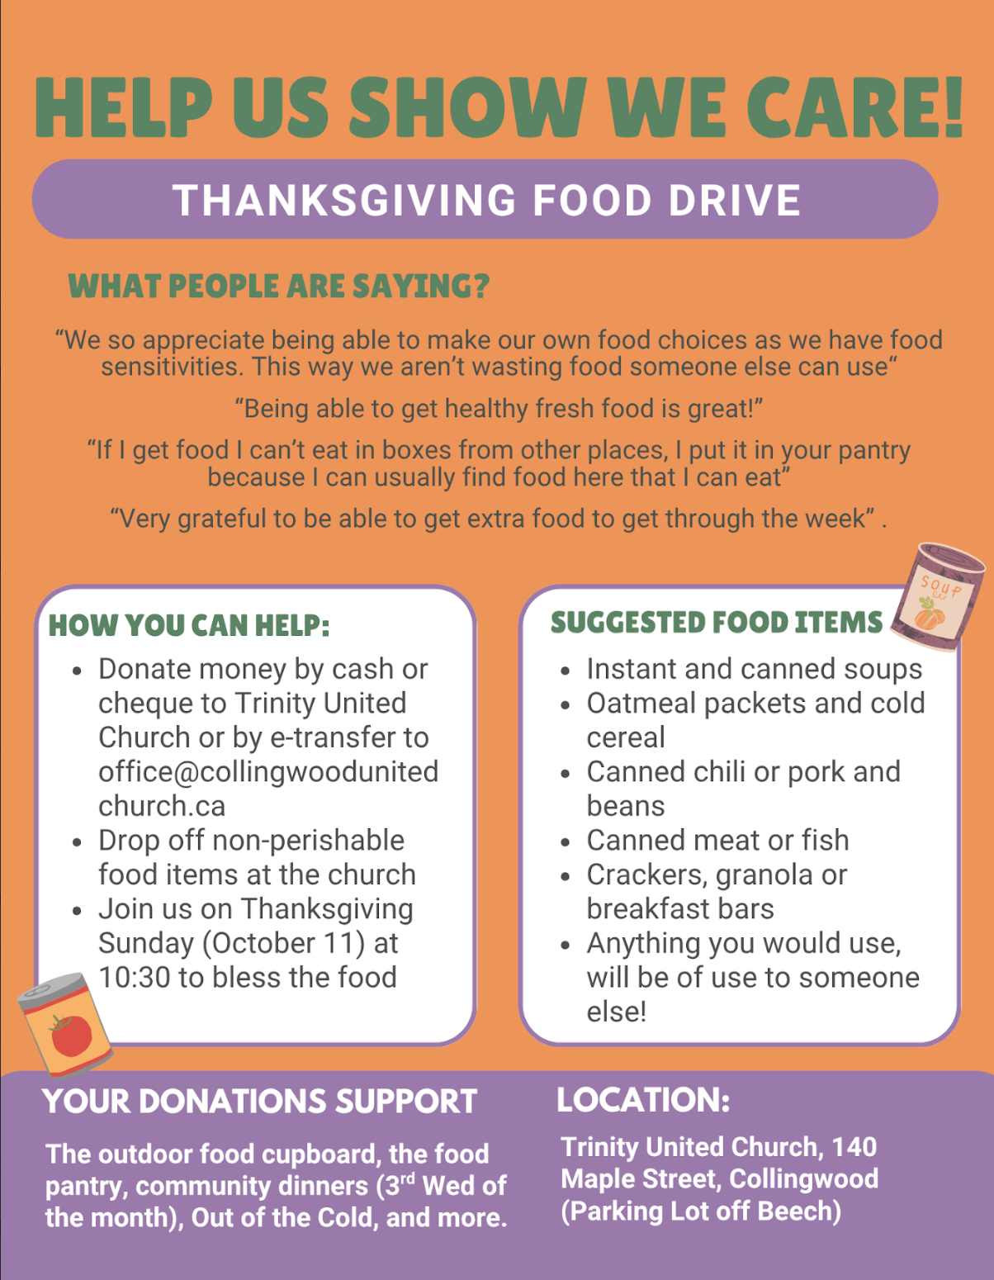

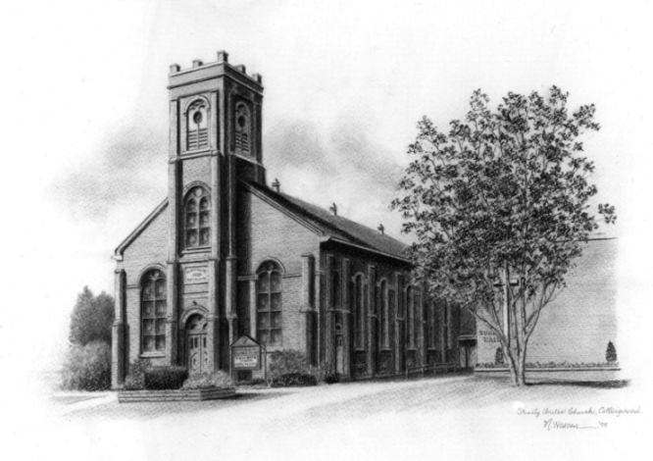
Trinity United .Church: Collingwood
Minister: Rev. Beth Kerr, 204.872.2370 (cell)
Minister’s Email minister@collingwoodunitedchurch.ca
Ministry of Music: Paul Sloan, 705.730.3121 (cell)
Choir Director: Lesley Joosten, 705.984.3243
Handbell Director: Maryellen Burgess, 705.443.1422 (cell)
UCW President: Joy Barr 705.445.0726
Office Assistant: Lori Forsythe
Church Office: office@collingwoodunitedchurch.ca
Office Hours: Tuesday to Friday, 8:30 am-12:00 pm
140 Maple Street, Collingwood, ON L9Y 2P8
Telephone: 705.445.3901
Website: www.collingwoodunitedchurch.ca

