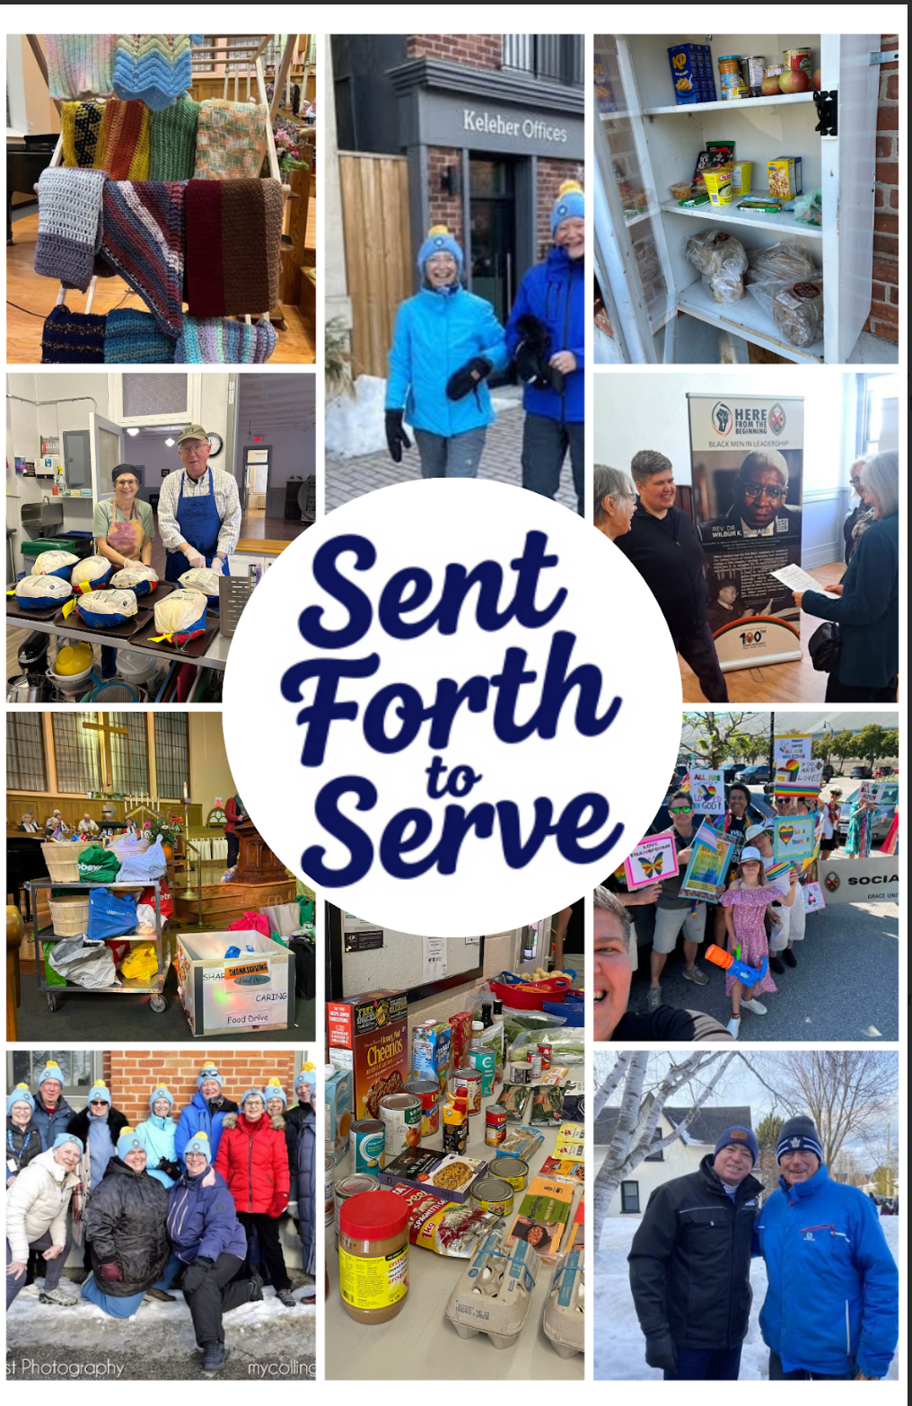


Trinity United Church
October 4, 2026
Ordinary Time
Nineteenth After Pentecost
World Communion Sunday
“Sent Forth to Serve”

Land Acknowledgement Explanations (please be seated)

God Welcomes Each One of Us with Loving Grace

Lighting the Christ Candle
We light this candle as a reminder of our commitment to follow in the way of Jesus.

Introit: TLUS 150 “Here in this Place” Words and Music: Maria Case (see insert)

Announcements and Opportunities @Trinity

Gathering Words
One: As an Affirming congregation of The United Church of Canada, we seek to be an inclusive and safe community, nurturing spiritual growth, responding to community and world needs, where everyone feels at home and no one feels alone.
All: We are all invited guests of God.

Opening Hymn: VU 477 “I Come with Joy”

Opening Prayer
God of all times and places, today we gather around Christ’s table with those seated beside us in the pews, those who are joining us online through YouTube, those who have gone before us in this place, and those around the world who gather at other communion tables to share in this sacred meal. We ask you to bless this time of worship that it might nourish us in our faith and equip us to serve generously in our daily lives.

Prayer of Confession
God of all the world, we know your love stretches far and wide and encompasses all living things. Yet, often we are tempted to limit our own circles of care to the people we know, the people we like, the people who are like us. On this World Communion Sunday, forgive us for our smallness of vision and help us to embrace a love like yours.

Pause for silent reflection

Assurance of Pardon
In God’s love, we are made new each day. Let us open our hearts to the grace which is the ground of our being. We are a forgiven people. Thanks be to God.

Theme Conversation (Children’s Time) – “Serving Others”

Hymn - MV 28 “God of the Bible”

God Speaks to Us with Peace and Assurance

Prayer for Illumination
Welcoming God, we receive with joy your invitation to come and feast on your word. We are hungry for good news! Help us to listen with our minds and our hearts so that we might experience what goodness you have for us today and rediscover how we might share that goodness with others. Amen.

Epistle: James 2: 14-19, 26

Psalm 19 (VU 740-741)

Gospel: Matthew 25: 31-40

Anthem: TLUS 1 “Simply to be”

Message: “Sent Forth to Serve”

Hymn -TLUS 143 “Cast Your Boat Out”

God Supports and Lifts Us

Acknowledging our Offerings in Support of Trinity United’s ministries
As part of the worldwide family of faith, we share our gifts both locally for the ministry of Christ here in Collingwood and area but also across the country and around the world through our gifts to Mission and Service. If you are able to support us financially, cash or cheques can be left in the offering plate at either entrance or mailed or dropped off at the church office. You can also give by e-transfer to office@collingwoodunitedchurch.ca or by signing up to donate monthly through PAR. If this is your first donation, please make sure we have your name and address and email address (if available) for tax receipt purposes. Thank you for all the ways you support us with your time, your talents and your financial resources. With grateful hearts we pray:

Generous God of boundless mercy and care, may our offering today make a different in the unnoticed and unknown places where your love is most deeply needed. Inspire us to sustain your ministries of hope and encouragement, of peace and acceptance. Extend our service to reach the corners of our communities and our world where your presence is longed for. Amen.

Invitation to Communion (by Florence Niven)

Communion Prayer (Modified from Celebrate God’s Presence, Prayer B)
One: May God be with us.
All: God is here among us.
One: Let us open our hearts to God.
All: We open them to God and to one another.
One: Let us give thanks to God.
All: It is right to give our thanks and praise.

One: We thank you, God, Creator of us all; ….
Alive for evermore!
Therefore with all the saints of every time and place:

Choir TLUS 16 “Sanctus and Benedictus”

One: We gather at this table to remember
…. Each time you do this, remember me.”

Bread is broken

One; That same night, Jesus also took a cup,
… Whenever you drink it, remember me.”

Cup is poured

One: We remember Jesus’ death and celebrate his resurrection,
we await with hope his coming again,
to bring peace and justice to the earth;
and we proclaim the mystery of our faith as we sing:

Choir TLUS 17 “Memorial Acclamation”

One: Send, O God, your Holy Spirit upon us and what we do here,
… All glory is yours, God most holy,
now and forever.

Choir TLUS 18 “Great Amen”

Sharing the Bread and the Cup
Everyone who wishes to share in communion today is most welcome to do so. Please come forward to receive a piece of bread and a small cup of juice. If you prefer gluten free bread, it is on the communion table for you to self-serve to prevent cross contact. Please place your cup in the empty tray at the side of the front before returning to your seat. If you prefer, you may come forward and cross your arms to receive a blessing instead of communion or you may remain in your seat. If you would like to receive communion in your seat, please indicate that to the servers by waving (or having someone let us know) and we will be delighted to bring it to you.

Prayer after Communion (from Celebrate God’s Presence)
Eternal God, we thank you that you have called your people from east and west, north and south, to feast at the table of Jesus Christ. Keep us faithful to your will. Go with us to the streets, to our homes, and to our places of labour and leisure — that whether we are gathered or scatted, we may be the servant church of the servant Christ, in whose name we pray by sharing the prayer of the worldwide Christian Church:

Prayer of Jesus (sung TLUS 70, see insert)

Closing Hymn - VU 481 “Sent Forth by God’s Blessing”

Commissioning (from re:worship)
As you go from here, remember to love. For love is what God asks of us; it is the very heart and soul of what it means to follow Jesus Christ. So go from here to love and serve God by loving and serving those you meet.

Benediction (from re:worship)
And may God— who loved us first, and who showed us what real love looks like— be with you and among you wherever you find yourself in the coming week. Go in peace! Amen.

Choral Blessing - VU 962 “May the Blessing of God”

Music to Inspire Our Serving
*************************************************************************************

